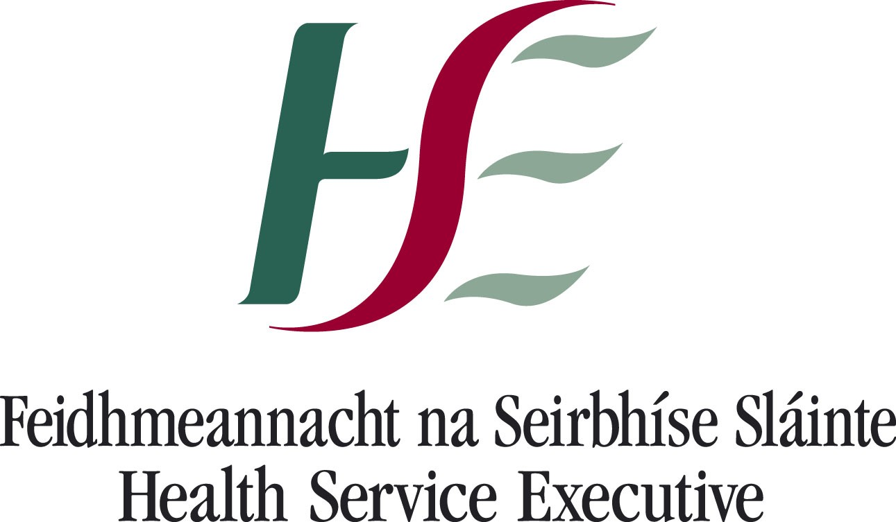National Counselling Service
Covid-19 Practical Tips

Some practical tips for those impacted by Covid-19 to consider before contacting the telephone counselling service:
- Anxiety is a mental and physical reaction to perceived threats. In small doses, anxiety is helpful. It protects us from danger and focuses our attention on problems. But when anxiety is too severe, or occurs too frequently, it can become debilitating.
Tip: Stop, breathe, relax, and repeat. The goal of anxiety management is to make contact with the present moment in order to defuse the thoughts you are experiencing. We can do this by taking a step back and detaching from our overwhelming, thoughts, images and memories. While doing this remind yourself of the challenges you have overcome in life, the things you are good at that may be beneficial to you during this time and the things you value most. If you are finding this difficult to do, stop your thoughts and pay attention to the physical world around you, name all the items you can see around the room you are located in, i.e. chair, light etc. Once you have done this and feel grounded enough to do so, return to exploring your strengths.

- Self-care is an activity or activities we deliberately partake in that have a benefit in our mental, physical and emotional health. Low mood and significant changes can sometimes inspire a lack of care for one’s condition: a loss of appetite or motivation, or a lack of energy. All of these can impair the ability to care for one’s self.
Tip: Create a self-care plan for your time in self-isolation; this plan will be unique to you (what works best for me might not work best for another person). Having a self-care plan in place will make a big difference during this time. Begin by exploring some practical, easy to take measures which you can implement. Some examples would be; keeping a daily journal during your time in isolation; set designated daily time to talk with loved ones via phone, Facetime, WhatsApp etc.; schedule daily safe exercise/stretching activities; practice mindfulness/relaxation/ breathing exercises daily; adapt a healthy sleep routine.

- Resources recommended for those who are comfortable accessing tools online include;
- Podcasts:
Coronavirus Special: How to manage anxiety in the face of a global pandemic (Dr Rangan Chartee with special guest Dr Judson Brewer)
Self Compassion; the proven power of being kind to ourselves (Kristen Neff)
- Websites:
http://franticworld.com/free-meditations-from-mindfulness/ - Mark Williams is a mindfulness practitioner who provides 8 free online mindfulness exercises on this link.
- Apps:
Insight Timer App (Provides a library full of various relaxation and meditation techniques)
Headspace App (Mindfulness based app)
Destressify App (the free version - this app provides a program for stress reduction)

